CV of Faculty
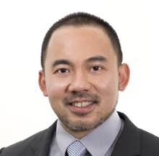 | James Yu (Australia)
Personal Profile: | Dr. James Yu is the Medical Director of Sydney Spine and Pain with several multi-disciplinary pain centres across Sydney. In 2016, he established Australian Medical Re-search (AMR), a private clinical research facility in Sydney. He is an active fellow of the Faculty of Pain Medicine in Australia (FFPMANZCA). He is an examiner and training unit assessor for the Faculty of Pain Medicine. He has been certified and awarded the Fellowship in Interventional Pain Practice (FIPP) in 2015. He is the treasurer for the Australian section of World Institute of Pain (WIP).  Dr. Yu is an executive board member of the Neuromodulation Society of Australia and New Zealand (NSANZ). He is trained in all areas of pain medicine with clinical expertise in interventional pain procedures including spinal cord stimulation and intrathecal pump implant.

CV of Faculty
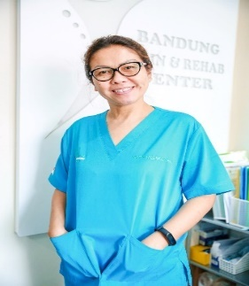 | TCT Novy (Indonesia)
Personal Profile: | Dr. Novy is Director of Bandung Pain & Rehab Center, Magister in Medical Nutrition, University of Padjadjaran, Bandung, Indonesia; and Director  of the Indonesian Pain Academy. She is a Certified Interventional Physiatrist, Indonesia PM&R Collegium, MD (Physiatrist), Physical Medicine & Rehabilitation, University of Padjadjaran, Bandung; Magister in Physiology and Sports Medicine, University of Padjadjaran, Bandung.

CV of Faculty
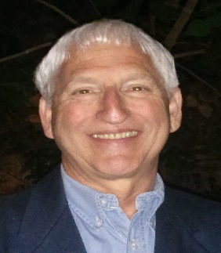 | Marshall Devor (Isreal)
Personal Profile: | Marshall Devor is the Alpert Professor of Pain Research at the Hebrew University of Jerusalem (HUJI). He was born in Toronto, Canada in 1949. His bachelor’s degree is from Princeton University (1970) and his PhD from MIT (1975). He was a postdoctoral fellow with the pain research pioneer Prof. P.D. Wall at University College London and subsequently at HUJI. There he progressed from Research Associate (1977) to Senior Lecturer, Associate Professor and finally Professor in 1988. His research has focused on the neurobiology of neuropathic pain, and more recently also on mechanisms involved in loss of consciousness and pain-free surgery. His laboratory has published extensively in the pain field, with work of a notably integrative nature involving neurophysiology, computer simulations, neuroanatomy (light and electron microscopy), genetics, and behavioral models. He is author of ~300 publications, career citations ~25,000, h-index = 78.

CV of Faculty
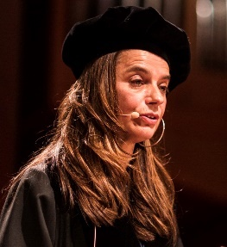 | Monique Steegers (Netherlands)
Personal Profile: | Biography Prof. Monique Steegers, MD, PhD, FIPP, anesthesiologist – pain and palliative specialist  Monique Steegers is a professor since 2019 for pain- and palliative care at the Amsterdam University Medical Centers location VUmc and is connected as an anesthesiologist pain-specialist to the anesthesiology department. She wants to improve the quality of life especially for patients with acute and chronic pain and for those patients having pain and cancer in every stage of their life. This is by improving painpractices by education and research. She is internationally known as the registrar of an interventional pain-exam since 2015, the FIPP and the CIPS from the WIP, and she is the chair of the Benelux chapter of the INS.  Before working in Amsterdam she worked more than 27 years at the Radboud university medical center, in the end as an associate professor and a junior principal lecturer.  Main interest of research and education: multidisciplinairy education of pain and supportive medicine, the mechanism of chronification, the treatment of acute- and chronic neuropathic pain and pain caused by cancer.

CV of Faculty
 | Kris C.P. Vissers (Netherlands)
Personal Profile: | Chair, Board of Examination and Past President of WIP Prof. Dr. Kris C.P. Vissers, MD, PhD, FIPP is anesthesiologist, professor in Pain and Palliative Medicine and chairman of the Radboudumc Expertise Center of Pain and Palliative Medicine of the Radboud University Nijmegen Medical Centre in the Netherlands. He is also scientific chairman of the Department of Anesthesiology, Pain and Palliative Medicine of this University. He is chair of the Radboud-ESMO training center for integrated oncological and palliative care and of the comprehensive Center of Excellence in Pain practice of the World Institute of Pain in Nijmegen. He is a past president of WIP and currently the chair of the Board of Examination for the FIPP/CIPS examination. He is author of more than 180 publications in international peer reviewed journals and contributed to more than 26 textbooks. He contributes to local and national education with regular articles in Belgian and Dutch journals for physicians and for the lay public. He is frequently asked as keynote speaker during national and international congresses and teaching courses. He organized 9 international congresses and workshops of which two world congresses. He was member of several scientific committees of congresses.

CV of Faculty
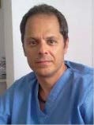 | Ovidiu Nicolae Palea (Romania)
Personal Profile: | Ovidiu Nicolae Palea was born in Blaj, a small town in the heart of Transylvania. He graduated from the Carol Davila University of Medicine and Pharmacy in 1989 and continued on graduating from his residency program in Anesthesiology at George Washington University Hospital, Washington DC, USA in 2003. After graduating from an Intensive Care fellowship from the same University Hospital a year later, he continued to work at Washington Hospital Center until the end of 2009 when he returned For good to Romania. He started his pain management practice in 2011, being the first Romanian to be accredited in Pain Management by the World Institute of Pain in august 2017. In 2018, his practice became the only Medical training facility in Eastern and Central Europe to be approved as a training facility by the European Society of Regional Anesthesia and Pain Therapy. He has extensive expertise in spine endoscopy, holds regular workshops in a wide variety of minimal invasive pain management procedures across the world, and has been included in the list of approved examiners by the World Institute of Pain.

CV of Faculty
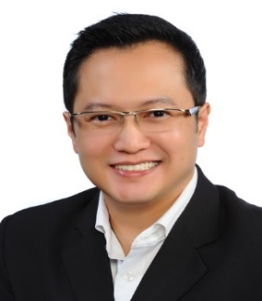 | Nicholas Chua (Singapore)
Personal Profile: | Dr. Chua is the Medical Director and Senior Consultant, Pain Medicine and Anesthesiology at Specialist Pain International Clinic, Mount Elizabeth Novena Hospital, Singapore. He graduated from the Faculty of Medicine, National University of Singapore (NUS) where he also obtained his Masters of Medicine (Anesthesiology). He completed his advanced specialist training in Anesthesiology in TTSH, Singapore, where he served as Head of Acute Pain Service, Dept. of Anesthesiology. Pursuing his sub-specialty interest, he completed his Fellowship of Interventional Pain Practice (FIPP) accreditation in 2007 by the World Institute of Pain in Tennessee, USA and his Ph.D from the Radboud University, Nijmegen, the Netherlands. Dr.Chua is the current President of the Pain Association of Singapore; Secretary of the Chapter of Pain, Academy of Medicine (Singapore); and sits on the examination board of the World Institute of Pain (WIP).

CV of Faculty
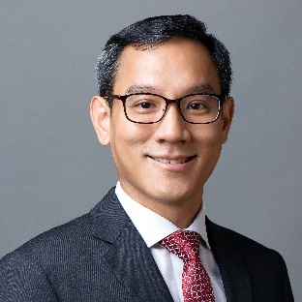 | Kok-Yuen Ho (Singapore)
Personal Profile: | Dr. Ho is a Consultant in Anaesthesiology and Pain Management. He holds an MBBS and MMed (Anaesthesiology) from the National University of Singapore. He completed a Pain Management Fellowship at Duke University Hospital in Durham, North Carolina, USA, and is a certified Diplomate with the American Academy of Pain Management (DAAPM). He completed his Fellowship of International Pain Practice (FIPP) with the World Institute of Pain (WIP) in 2006 and currently serves as Chairman of the South-East Asian Section for WIP as well as an examiner on the FIPP Examination Board. He was the Past President of The Pain Association of Singapore from 2011-2017 and Past Vice-President of the Association for South-East Asian Pain Societies (ASEAPS) from 2012-2013.  Dr. Ho’s clinical and research interests include nonsteroidal anti-inflammatory drugs (NSAIDs), adjuvant therapy for chronic post-surgical pain, as well as implantable therapies for failed back surgery syndrome and advanced cancer pain. The first physician in Asia to perform cooled radiofrequency ablation, he has been treating spine, sacroiliac, hip and knee pain using this technique since 2006.  He has published more than 50 peer-reviewed journal articles and book chapters on pain and anaesthesia. He has also delivered more than 200 lectures at regional and international conferences, and frequently serves as an instructor at interventional pain cadaver workshops.

CV of Faculty
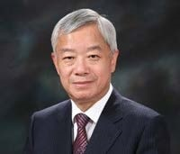 | Sang Chul Lee (South Korea)
Personal Profile: | Prof. Sang Chul Lee is Professor Emeritus of Seoul National University College of Medicine. He is an anesthesiologist who majors pain management. He is one of the expert in spinal non-surgical procedure, such as extraforaminotomy, L-disq and trans-sacral epiduroscopic lumbar decompression. He tried spinal cord stimulation, radiofrequency technique and pump implantation in Korea for the first time. He studied pain management at UCLA from 1988 to 1990. Then, he opened pain clinic in Seoul National University Hospital, which is one of EPP. He served as the President of World Society of Pain Clinicians Korean IASP Chapter, Korean Pain Society, Korean Society of Anesthesiologist, and Asian Australasian Federation of Pain Societies.  He gave lectures at international meetings close to 200 times and published more than 230 articles. He is one of the honorary member of Taiwan Pain Society, and recently, he opened his own private practice in Seoul.

CV of Faculty
 | Jee Youn Moon (South Korea)
Personal Profile: | Dr. Moon is an Associate Professor in the Department of Anesthesiology and Pain Medicine at the Seoul National University Hospital in Seoul, South Korea. She has published various articles in many journals, ranging from “An Alternative Distal Approach for the Lumbar Medial Branch Radiofrequency Denervation in ”Anesth Analg” to “Cervical Epidural Pressure Measurement: Comparison in the Prone and Sitting Positions” in Anesthesiology. Dr. Moon received the Award for Excellent Research Prize from the Korean Pain Research Society. She represented the Korean Pain Society for making the Consensus guidelines on lumbar facet joint pain interventions from a multispecialty, international working group. Dr. Moon won the Best Speaker Award from the Korean Pain Society for the field of ultrasound-guided pain medicine as well. Her current interests are in the management of cancer pain, opioid safety, and managing CRPS. She has delivered several lectures in New York and Taipei, AAPM in Pheonix, San Francisco, Vancouver, Denver, Washington D.C., and WAPMU in Miami. Dr. Moon is a Director of the International Cooperation of the Korean Pain Society and an active member of the Korean Society of Anesthesiologists. She is also concurrently the Director of the Pain Center at Seoul National University Hospital and Cancer Pain Management Center at Seoul National University Hospital.

CV of Faculty
 | Ricardo Ruiz-López (Spain)
Personal Profile: | Ricardo Ruiz-Lopez, MD, Neurosurgeon, FIPP, is a Founder and Past President of WIP. He is also a Founder of EFIC (1993) and President of its II Congress Pain in Europe in (Barcelona,1997). He has been Founder of the Spanish Pain Society (1989) and Founding President of the Catalan Pain Society (2001) as well as various International Spine Societies. Throughout a continuous Founding process in WIP, he has been the promoter of the WIP FIPP® Examination into Spanish and English for the Americas in Miami, USA, (2012) and promoter from 2015 and Founder of the FIPP® / CIPS® Examination at Taipei, National Taiwan University, Taiwan, initiated in 2019 with the support of the Taiwan WIP Registered Society and the National Taiwan University, holding its 3rd Symposium & Workshop on January 30-31, 2021. He has been distinguished with the Trail Blazer Award of World Institute of Pain (2017).

CV of Faculty
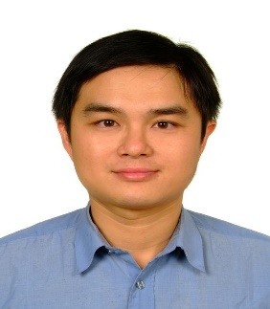 | Ke-Vin Chang (Taiwan)
Personal Profile: | Dr. Chang is the Clinical Associate Professor of National Taiwan University Hospital, Taipei, Taiwan and the founder of USMSIT (Ultrasound Musculoskeletal Workshop in Tai-wan) and NMUSIT (Neuromuscular Ultrasound Workshop in Taiwan).

CV of Faculty
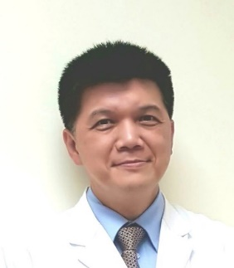 | Yi-Pin Chiang (Taiwan)
Personal Profile: | Dr. Yi-Pin Chiang is currently vice president of Taiwan Society of Neuromusculoskeletal Ultrasound (TNMSKUS). He is a senior Attending Physician of Department of PM&R in MacKay Memorial Hospital, Taipei, Taiwan, and also an assistant professor of Mackay Medical College. Dr. Chiang finished his fellowship in 2004 at department of Bone Radiology of Henry Ford Hospital, Michigan, USA. He began to devote himself in musculoskeletal ultrasound practice and teaching since then. His main interest of study and research are musculoskeletal ultrasound in sports injury and pain intervention.

CV of Faculty
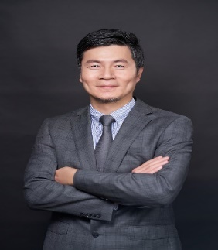 | Ming-Hsiao Hu (Taiwan)
Personal Profile: | Clinical Assistant Professor, Orthopedics, National Taiwan University College of Medicine  Attending Surgeon, Department of Orthopedics, National Taiwan University Hospital  Secretary-general, Taiwan Spine Society

CV of Faculty
 | Chih-Peng Lin (Taiwan)
Personal Profile: | Dr. Lin is the Chief of the Division of Pain Medicine, Dept. of Anesthesiology at the National Taiwan University Hospital (NTUH), with a joint appointment as Attending Physician in the Department of Oncology. He is also Associate Professor, College of Medicine, National Taiwan University. His major research interests are mechanisms and possible therapeutic approaches for neuropathic pain and opioid tolerance/hyperalgesia, new interventional technique development and outcome research of image guided interventional procedures. He is passionate about education and interventional management for chronic pain, especially refractory cancer pain, with additional expertise in multimodality guided pain intervention. He is the course organizer of the ultrasound tract of 1st and 2nd WIP Taipei annual symposium and interventional pain workshop.

CV of Faculty
 | Chia-Shiang Sean Lin (Taiwan)
Personal Profile: | Dr. Chia-Shiang (Sean) Lin is the Chief Director of Pain Management Center at Mackay Memorial Hospital, Tai-wan. He has involved in the development of the post operative pain management and engaged the chronic pain clinic since 1995. Presently, he is involved in the research interests about the cancer pain; chronic spinal pain; chronic neuropathic pain and imaging guided interventional pain management. He had been a visiting stuff at many Pain Centers of USA and Europe including MD Anderson Cancer Center, Texas Tech University Health Sciences, University of Stanford and Cleveland Clinic. Dr Lin is the pioneer of the ultrasound guided regional anesthesia and pain management in Taiwan since 2005. Right now, Dr. Lin has taken the responsibility of the 14th President of Taiwan Pain Society since April 4th, 2015 till April 2017. After he has got the double certification of CIPS and FIPP together in 2016, he has been invited to be the Examiner of the FIPP&CIPS Examination at Annual meeting of WIP & WAPMU in Miami Jan, 2017 and 1st WIP Taipei East Asia Interventional Pain Workshop, 2019.

CV of Faculty
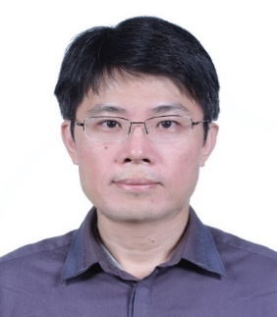 | Feng-Sheng Lin (Taiwan)
Personal Profile: | Dr. Lin graduated from the National Taiwan University as a Doctor of Medicine (M.D.). Currently he is a Pain Physician and Anesthesiologist at NTUH. In 2018 he received his Fellow of Interventional Pain Practice in London.

CV of Faculty
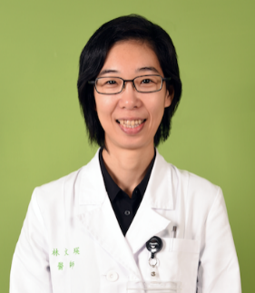 | Wen-Ying Lin (Taiwan)
Personal Profile: | Dr. Lin is a Pain Physician and Anesthesiologist in National Taiwan University Cancer Center and Hospital. Dr. Lin graduated from Chung Shan Medical University and completed her anesthesiology and pain training in National Taiwan University Hospital, and as a visiting staff in Peter MacCallum Cancer Centre, Melbourne, Australia.

CV of Faculty
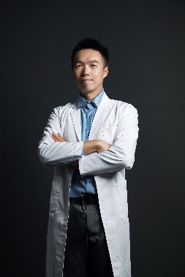 | Ping-Tang Liu (Taiwan)
Personal Profile: | Dr. Liu dreamed of integrating manipulation techniques, empower exercise, prolotherapy and ultrasound techniques together. Xiang-Yang rehabilitation clinic was established in 2018, just next to Samurai Fitness Gym. To repair injured ligaments and tendons, to reset osteopathic dysfunctions, to rebuild good motor patterns are their common aspiration. Ultrasound techniques are good to verify the clinic diagnosis, to visualize osteopathic dysfunctions and to check if motor recruitment is in correct order. He decided to dive in this field.

CV of Faculty
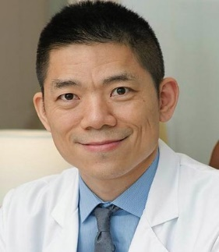 | Jen-Li Pan (Taiwan)
Personal Profile: | Dr. Pan is an Attending Physician, Department of Physical Medicine and Rehabilitation, Taipei Medical University Hospital, Taipei, TAIWAN; Medical Director, Pan Regenerative Pain Clinic, Taipei, TAIWAN; and had served as the social media director for the World Academy of Pain Medicine Ultrasonography (WAPMU).

CV of Faculty
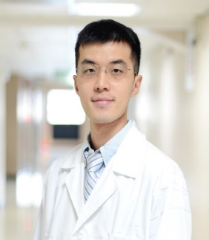 | Daniel Chiung-Jui Su (Taiwan)
Personal Profile: | Dr. Su is board certified in Physical Medicine and Rehabilitation. He is the teaching faculty of Taiwan Association of Prolotherapy and Regenerative Medicine, Taiwan Pain Society, and Ultrasound Musculoskeletal Workshop in Taiwan. Dr. Su specializes in Ultrasound Guided Regenerative Medicine, Osteopathic Manipulation and Performing Arts Medicine. Dr. Su is also an active Cellist with several orchestras and establishes injury prevention program for musicians nationwide.

CV of Faculty
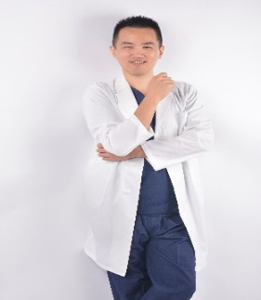 | Donald Tsung-Yung Tang (Taiwan)
Personal Profile: | Research Field:  慢性疼痛(Chronic Pain Management)  影像導引疼痛治療(Image-guided Interventional Pain Medicine, ultrasound and fluoroscopic-  guidance)  區域阻斷麻醉(Regional Anesthesia)  Current Position:  馬偕紀念醫院麻醉部疼痛科 主治醫師 2020.1~  臺灣疼痛醫學會 副秘書長 2019.4~  世界疼痛醫學會台灣分會 副秘書長 2020.7~  Education and Training:  2003 - 2010, National Taiwan University, School of Medicine, M.D.  2010 - 2012, Residency, Department of Surgery, Taichung Veterans General Hospital, Taichung,  Taiwan  2012 - 2016, Residency, Department of Anesthesiology, Taichung Veterans General Hospital,  Taichung, Taiwan  2016 - 2017 Fellowship, Division of Pain Management, Department of Anesthesiology, Taichung  Veterans General Hospital, Taichung, Taiwan  2017.3 - 2017.9 Observorship, Pain Management Center, Mackay Memorial Hospital, Taipei, Taiwan,  2017.12-2019.12 Attending Physician, Division of Anesthesiology, Chiayi Branch of Taichung Veterans General Hospital

CV of Faculty
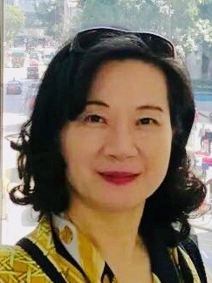 | Yu-Chuan (Grace) Tsai (Taiwan)
Personal Profile: | Prof. Yu Chuan (Grace) Tsai is Professor of Anesthesiology and Chief, Center of Pain Management at E-Da Cancer Hospital Kaohsiung Taiwan, also the Executive Director and former President of Taiwan Pain Society. She has served on the board of WSPC (World Society of Pain Clinicians) from 2008 to 2012 and the Chair of 2nd Asian Congress on Pain (AAFPS) in 2014. In 2019 and 2020, she organized the first and 2nd WIP Taipei Interventional Pain Workshop and East-Asian FIPP/CIPS Examination. Currently she is Chair of WIP Taiwan Registered Society and Program Co-director of 3rd WIP Taipei Interventional Pain Workshop. Prof. Tsai is a recognized pain specialist. She has published more than 85 articles on anesthesia and pain management including basic research in the field of opioid effects on immune system and wound healing. She also was editor of the book “Clinical Aesthesia – Experiences and Evidences” Her main interest field is in chronic headache and facial pain with focus on interventional pain management.

CV of Faculty
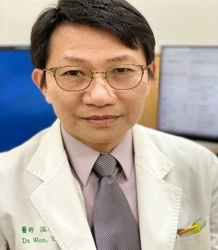 | Yeong-Ray Wen (Taiwan)
Personal Profile: | Prof. Wen is Head, Center for Pain Management and Research, and Associate Professor, School of Medicine , China Medical University. He earned his PhD degree from Taipei Medical University, Graduate Institute of Clinical Medicine, Taiwan; and his Bachelor degree from China Medical College, School of Medicine, Taichung, Taiwan. Dr. Wen completed his Residency in the Dept. Anesthesiology, National Taiwan University Hospital, Taipei, Taiwan; served as Attending Doctor, Dept. of Anesthesiology, Shin-Kong Memorial Hospital, Taipei and as Research Fellow, Dept. of Anesthesiology, Brigham & Women’s Hospital, Harvard Medical School, Boston.

CV of Faculty
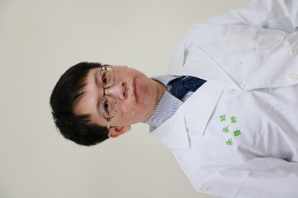 | Wei-Ting Wu (Taiwan)
Personal Profile: | Dr. Wu is a board certificated physiatrist. He excels in diagnostic and interventional ultrasound for musculoskeletal disorders. Dr. Wu is the adjunct lecturer and attending physician of Department of Physical Medicine and Rehabilitation, National Taiwan University Hospital, Bei-Hu Branch and National Taiwan University College of Medicine, Taipei, Taiwan.

CV of Faculty
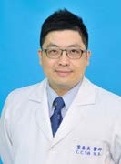 | Chun-Chang Yeh (Taiwan)
Personal Profile: | Dr. Yeh is Chairman, Dept. of Anesthesiology at Tri-Service General Hospital (TSGH), and Associate Professor, National Defense Medical Center (NDMC). He earned his PhD degree from College of Medicine Fu-Jen Catholic University, Taipei county, Taiwan, Currently he is an anesthesiologist and a Pain Physician at TSGH. In 2004 & 2005 he received his Fellow of Interventional Pain at Duke University Medical Center (DUMC), NC.

CV of Faculty
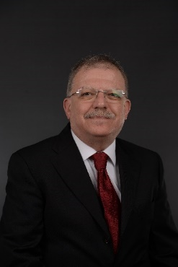 | Serdar Erdine (Turkey)
Personal Profile: | Prof. Erdine is a Founder and Past President of the WIP. He is the Founder and President of Turkish Society of Algology (1993-2015); Founder and Past President pf Turkish Society of Regional Anesthesia (1993-1995, 1998-2003); and has served in numerous other founding and leadership roles in professional societies through the world. Prof. Erdine is the recipient of the Young Leader in Medicine Award by the Turkish Jaysees (1991); the Lifetime Achievement Award Medical Chamber of Istanbul (2012); and the Trail Blazer Award by World Institute of Pain (2017).

CV of Faculty
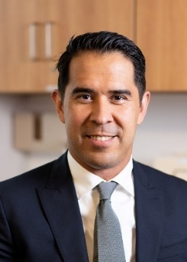 | Kenneth Chapman (USA)
Personal Profile: | Dr. Kenneth Chapman is the director of Research and Education at the Zucker School of Medicine at Hofstra pain medicine fellowship program. He is an assistant clinical professor at NYU Langone Medical Center and adjunct assistant professor at Hofstra Medical School. Dr. Chapman is the most recognized for his research in dorsal root ganglion stimulation as well as his expertise in spinal cord stimulation, vertebral compression fractures, and radiofrequency ablative treatments and speaks on these topics regularly around the world.

CV of Faculty
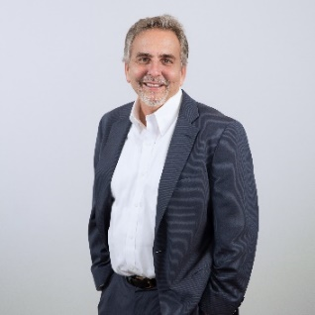 | Peter S. Staats (USA)
Personal Profile: | Dr. Staats was the Founder of Division of Pain Medicine at Johns Hopkins University, where he was the director for 10 years. Dr. Staats is internationally recognized for his work in developing and implementing minimally invasive procedures for chronic pain, and his inventions have led to the use high dose capsaicin (Qutenza patch), and noninvasive vagus nerve stimulation in covid 19. Dr. Staats received his medical degree from the University of Michigan Medical School in Ann Arbor and completed his residency and fellowship training at the Johns Hopkins University School of Medicine. He is a past President of the North American Neuromodulation Society, American Society Of Interventional Pain Physicians, New Jersey Society of Interventional Pain Physicians, and the Southern Pain Society. He is currently President elect of the World Institute of Pain and continues to serve as Chief Medical Officer for National Spine and Pain Centers, the largest pain practice in the USA.

